MODULE 4 – INTRODUCTION TO DBMS

LAB EXERCISES

9. DELETE command
Lab 1.
Remove all members who joined before 2020 from the members table.
Ans.
1. DELETE FROM members_backup WHERE date_of_membership < '2020-01-01';
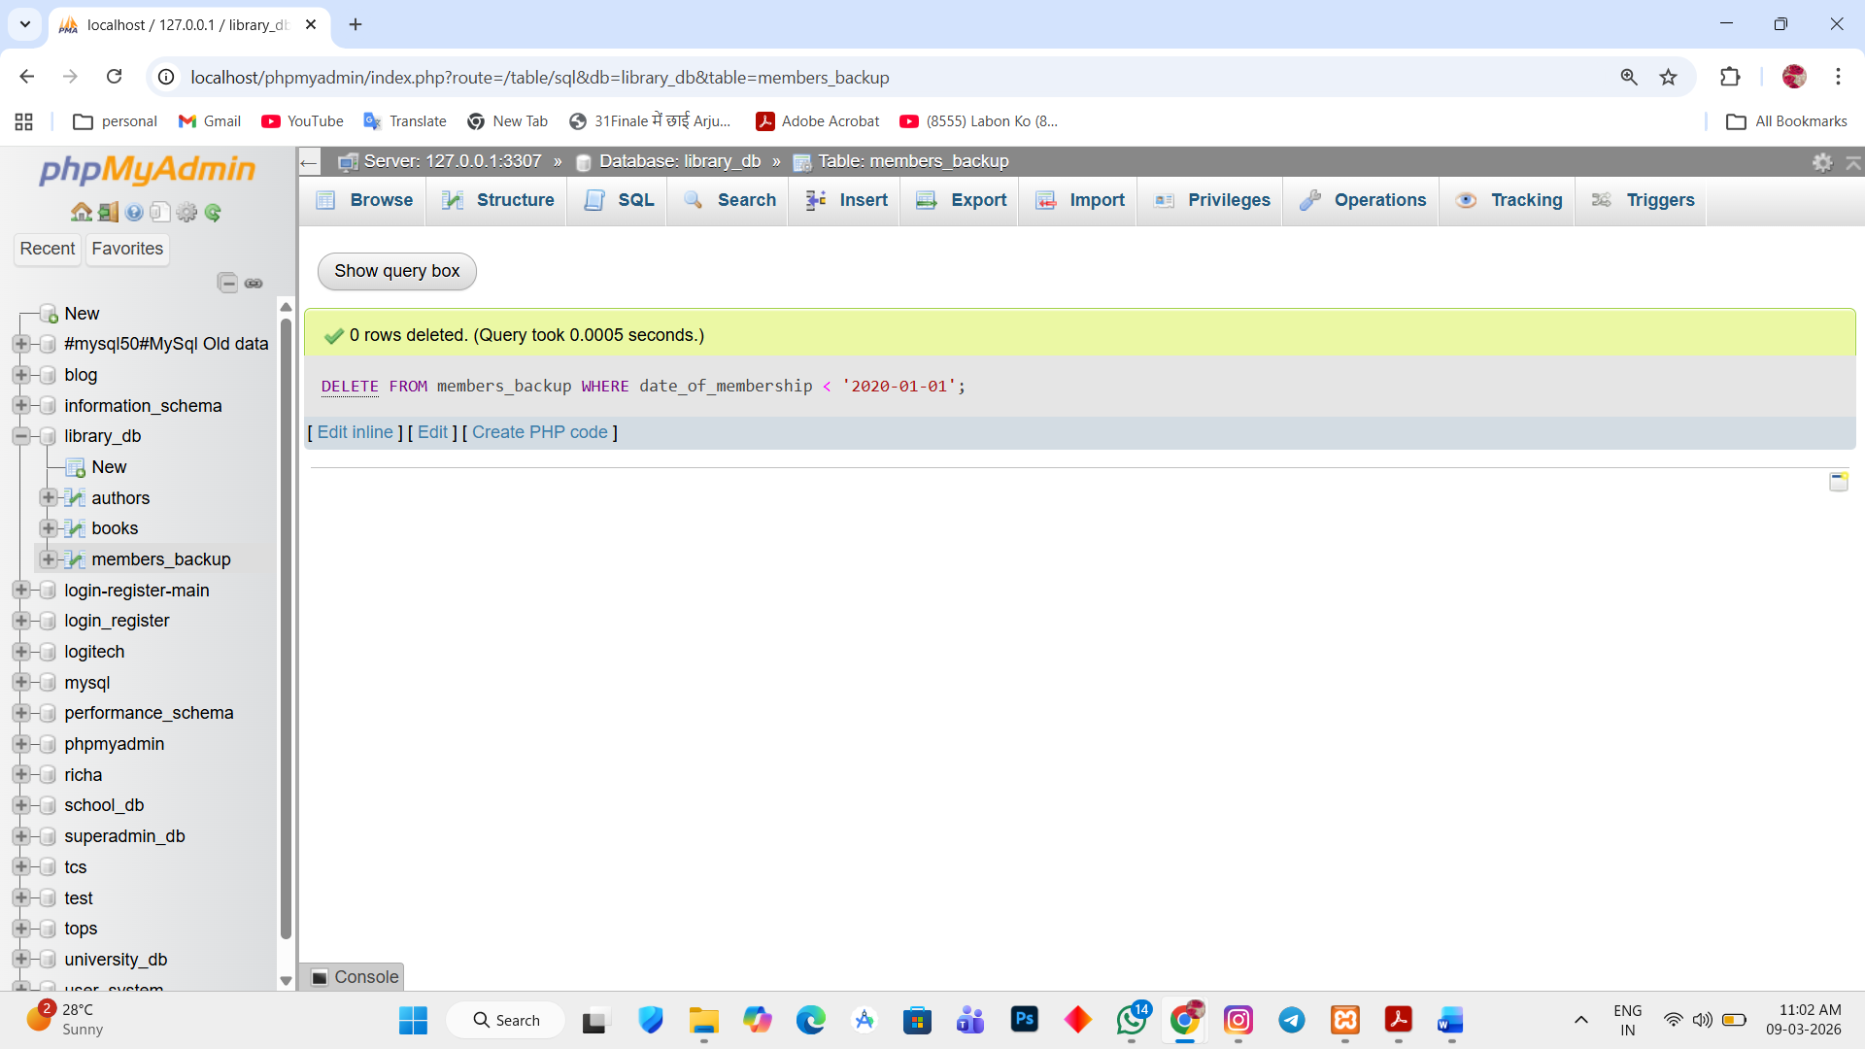

Lab 2.
Delete all books that have a NULL value in the author column.
Ans.
1. DELETE FROM books WHERE author IS null;
